Remaining Useful Life
Date: 13 March 2022
By: Isidor Buchmann
Status: Privileged Information
_____________________________________________________________________________________
All products have a Remaining Useful Life (RUL), governed by State-of-Health (SoH). This also applies to batteries, and improved SoH diagnostics lead to better RUL estimations. RUL assessments are based on capacity that tends to fade literarily with usage and age.  RUL needs a Minimum Viable Product (MVP) reference for given applications and with a lead acid starter battery this is a capacity of 30%. Passing the test at 40% promises one year grace, good to the next service. | 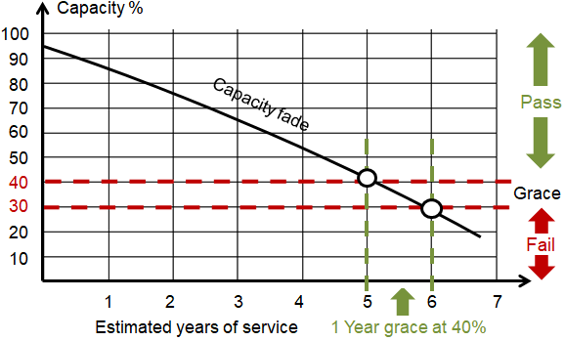  Estimated Remaining Useful Life of a starter battery
More accurate RUL estimations are attainable by tracking battery SoH with cloud analytics. Applications benefiting from these advancements are heathcare, public safety, defense, logistics, drones and robotics.
Portable batteries are increasingly fitted with the SMBus that provides FCC (full charge capacity) in the form of “digital capacity” serving as SoH reference. Up-and-coming Diagnostic Chargers also assess the capacity of regular batteries by reading the residual state-of-charge (SoC) with intelligent filtering and measuring the coulombs needed for a full charge. SoC plus charge represents the usable capacity. Tracking capacity fade over time enables RUL calculations to give the fleet supervisor the date when a battery should be replaced. Most portable batteries reach end-of-life when the capacity drops to 80%.
Depending on use, errors occur with smart batteries and the accuracy suffers. Before replacing a battery, performance should be verified by measuring the “chemical capacity” with a battery analyzer. Analyzers also calibrate a smart pack, measure the internal resistance, prepare batteries for storage, fulfill AirShip requirements with Li-ion, and verify performance before service.
SoH analytics with modern diagnostic chargers and analyzers run in the background. Diagnostic chargers are hybrid and service smart and dumb batteries side-by-side. Optional cloud connectivity paves the way to the RUBY System for optimal battery transparency with minimal user interaction.
Conclusion
Battery diagnostics has been lagging behind time comparing to RCM (Reliability-centered Maintenance) that predicts mechanical wear-and-tear. Batteries do more than power a flashlight. With assignments to replace fossil fuel-guzzling mechanical power sources, batteries can no longer be installed and forgotten. Modern battery diagnostic technologies are becoming available that look at the electrochemical evidence of battery systems to make RUL feasible with cloud analytics and artificial intelligence.
20220315 Documents\Product20\RUL.docx

