Battery Maintenance
How to Maximize Performance and Reliability of Rechargeable Batteries

DOE states that “every year roughly one million Li-ion batteries are sent in for recycling with most having up to 80% capacity.” According  to an FDA survey, “up to 50% of service calls in hospitals surveyed relate to battery issues.” AAMI reports that “battery management emerged as a top 10 medical device challenge.”  Battery maintenance assures that all batteries meet a minimal required performance level. Each battery is kept for its full service life and is only replaced when the capacity falls below the set capacity threshold. This results in improved reliability without fear of unexpected downtime.  The ready light deceives |  |  |  | 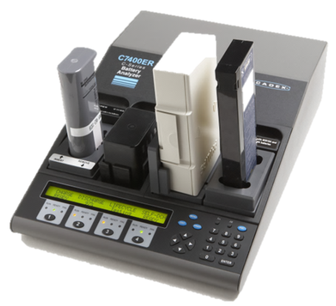  Cadex C7400ER Battery Analyzer  One bad battery can make a system unreliable
Ready does not mean “able.” It only tells that the battery is fully charged
Faded batteries charge quicker than good ones — there is less to fill.
Weak batteries gravitate to the top, disguised as combat ready
Knowing when to replace a battery  A battery should have a capacity of 100%; most packs in the field have less. With use and ageing, the capacity decreases and replacement should be at 70–80%.  Replacing batteries too soon increases operational cost; keeping them too long makes the system unreliable. Most packs are kept too long.  Battery maintenance permits balancing cost and risk. Measuring the spare capacity after a mission enables checking the reserve for the unforeseen. |  |  |  |  |  | 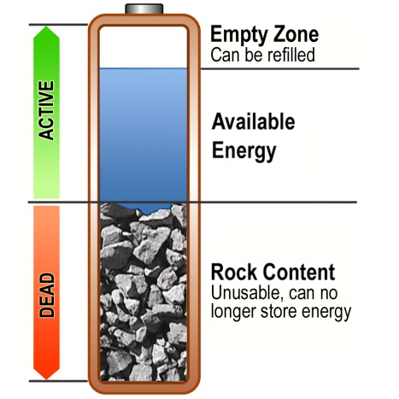
System Configuration  Batteries in daily use should be serviced every 1–3 months. A 4-station battery analyzer processes 160 batteries based on a monthly maintenance schedule. |  |  |  |  | The Cadex analyzers are automated to reduce the time required to service a large battery fleet to about 30 minutes per day.
Cadex C7000 Series battery analyzers are programmable to 36V (nominal) and 6Ah for the service of 24Ah batteries. The system works in standalone mode or with PC-BatteryShop™. | 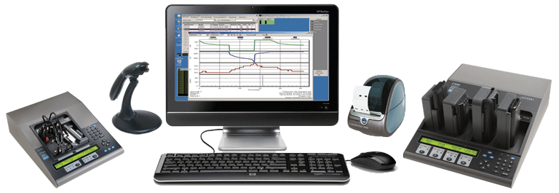 Cadex C7000 Series battery analyzers
Identifying each battery with a permanent bar code number simplifies battery maintenance. Scanning the code fetches historical battery information and test results that can be shared.
Another method is attaching a battery label showing capacity and resistance with service dates. PC-BatteryShop™ prints the labels.
Typical Applications |  |  | Payback calculations  Batteries have a defined life span. Many are replaced too soon but most stay too long.  Battery management typically cuts operating cost in half, paying for the investment in less than one year. Improved reliability is a side benefit of lower operating costs.
Public safety – defense – healthcare – mobile phones – two-way radios – portable computing – scanners – cameras – filming – broadcast – robots – drones – security – airports – seaports – delivery personnel – warehouse logistics – cargo – railways – expeditions – resorts – survey – mining – rentals – construction – service centers and many more.

Cadex Electronics Inc. | ISO 9001, ISO 13485
22000 Fraserwood Way, Richmond, BC, Canada V6W 1J6  Tel: 604 231-7777; 800 565-5228; Fax: 604 231-7755 |  | Farmstrasse 91-97, D-64546 Moerfelden-Walldorf, Germany Tel: +49 (0) 911 2403 32-0; Fax: +49 (0) 911 2403 32-29
info@cadex.com www.cadex.com

