Analyzing SINCGARS Batteries

The leading health indicator of a battery is capacity. Capacity represents the stored energy that governs the runtime. A battery also includes the empty that can be refilled and the inactive that expands as the battery fades. The growing inactive part will eventual govern the replacement.  At what capacity should a battery be replaced? Packs are often retired too soon, but most stay in service too long, affecting reliability. Cadex battery analyzers assist in finding the most cost-effective battery replacement plan. |  |  |  |  | 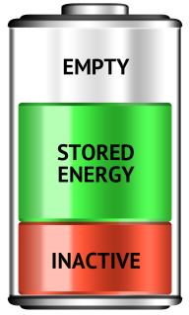
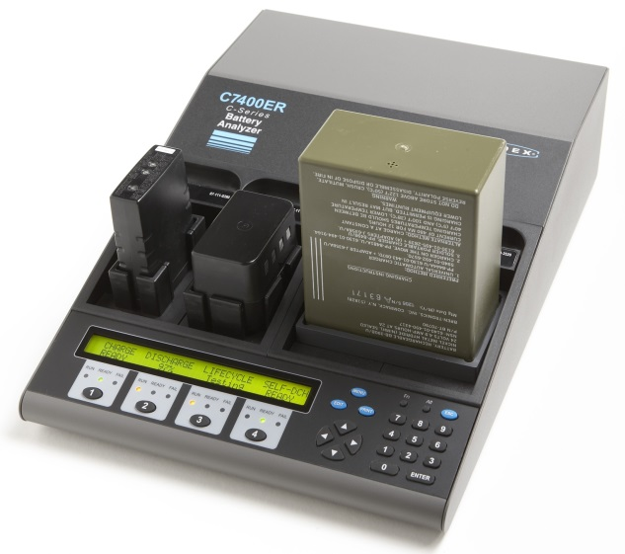  SnapLock™ Battery Adapters  SnapLock™ Battery Adapters |  | The SINCGARS Battery Analyzer  The Cadex C7400ER services two BB-2590, BB-390 or BB-590 simultaneously. Simply plug the battery into the custom adapter and select the chemistry. The “Auto” program measures the spare capacity after field use and then proceeds with a full battery valuation.  The four-channel C7400ER services batteries up to 36V at 6A charge and discharge. Cadex also offers a two-station version.  Smart Cable  Smart Cable
Custom adapters are available for all major batteries. The user-programmable Smart Cables service the less common packs. | 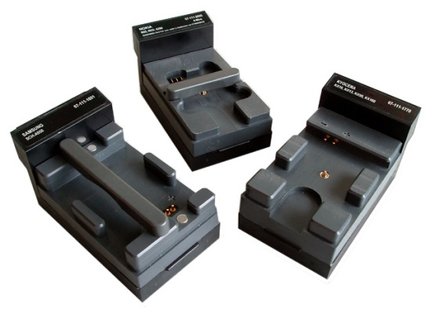 |  |  | 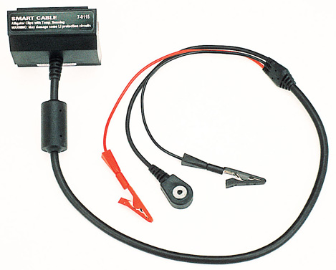
Service Programs  The Auto program provides a fully automated analysis; Prime prepares a new battery for service. Other programs perform life cycle tests, measure internal resistance and provide Boost. |  |  | Custom Programs (Entered by the PC)  Custom programs complete special tests consisting of charge, discharge, wait and repeats. You can set targets to alter the course of event if a condition is not met.

What does a Battery Analyzer Do?
Target Capacity Keeps a battery fleet at an acceptable operating capacity. Batteries that fall below the threshold are replaced.
Spare capacity Checks reserve capacity after a mission. Spot-checking reserve capacity assists in mission planning.
Labeling Offers battery information at a glance. Cadex also offers a bar code system that fetches historic information from a PC database. | 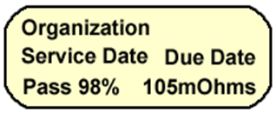
Battery testing with PC-BatteryShop™  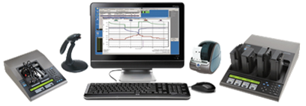  Optional PC-BatteryShop™ operates 32 analyzers for simultaneous service of 128 batteries (on most PCs |  | PC-BatteryShop™ passes the control of the C7000 Series to a PC. Clicking the mouse on any of the over 2000 batteries listed in the database or swiping the bar code on the battery label configures the analyzer. You can extend the library by adding new models or downloading the listing from www.cadex.com.
Specifications
System  Charge  Discharge  Dimension  Weight | C7200  2-station 1.2-15V, 4A/Stn  40W/Stn; 40W total  35W/Stn;70W total  12.1x9.4x3.5”, 305x240x90mm  7.1 lb; 3.2 kg | C7400  4-station 1.2-15V, 4A/Stn  55W/Stn; 80W total  35W/Stn; 140W total  14.4x11x3.8”, 366x280x97mm  10.05 lb; 4.54kg |  |  | C7400ER  4-station 1.2 -36V, 6A/Stn  75W/Stn; 170W total  75W/Stn; 200W total  15.4x11x4.2”, 391x280x107mm  12.1 lb; 5.5kg
Interface  Chemistry  Programs  AC voltage | SnapLock™ custom and universal battery adapters, programmable  Li-ion, NiMH, NiCd, lead acid; up to 24Ah. Auto scaling if set above 4A  4 basic; 10 advanced; 4 custom  100-240VAC, 50-60Hz |  | Display  Data Ports  Approvals  Warranty  PC-BatteryShop™ | 2x40, backlit; 3 light signals / station  USB for PC; RS-232 for printer  CSA/UL/PSE. RoHS, WEEE compliant  2 years for material and workmanship  License for 1, 4, 16 or 32 analyzers
Specifications subject to change

Cadex Electronics Inc. | ISO 9001, ISO 13485
22000 Fraserwood Way, Richmond, BC, Canada V6W 1J6  Tel: 604 231-7777; 800 565-5228; Fax: 604 231-7755 |  | Farmstrasse 91-97, D-64546 Moerfelden-Walldorf, Germany Tel: +49 (0) 911 2403 32-0; Fax: +49 (0) 911 2403 32-29
info@cadex.com www.cadex.com

