Battery Maintenance in Healthcare
How to Maximize Performance and Reliability of Rechargeable Batteries

According to an FDA survey, “up to 50% of service calls in hospitals surveyed relate to battery issues.” AAMI reports that “battery management emerged as a top 10 medical device challenge.” Meanwhile, DOE states that “every year roughly one million Li-ion batteries are sent in for recycling with most having up to 80% capacity.”  Battery maintenance assures that all batteries meet a minimal required performance level. Each battery is kept for its full service life and is only replaced when the capacity falls below the set capacity threshold. This results in improved reliability without fear of unexpected downtime.  The ready light deceives |  | 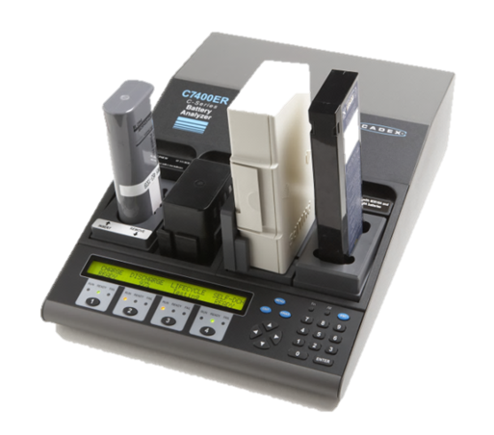  Cadex C7400ER Battery Analyzer  Recommended for Healthcare
 | Ready does not mean “able.” It only tells that the battery is fully charged. Faded batteries charge quicker than good ones because there is less to fill. Weak batteries gravitate to the top, disguised as combat ready, only to fail in the field
Knowing when to replace a battery  A battery should have a capacity of 100%; most packs in the field have less. With use and ageing, the capacity decreases and the battery should be replaced at 80%.  Replacing batteries too soon increases operational cost, and this may be the case with date-stamping. Keeping them too long makes the system unreliable.  Battery maintenance permits balancing cost and risk. Measuring the spare capacity after a mission enables checking the reserve for the unforeseen. |  |  | 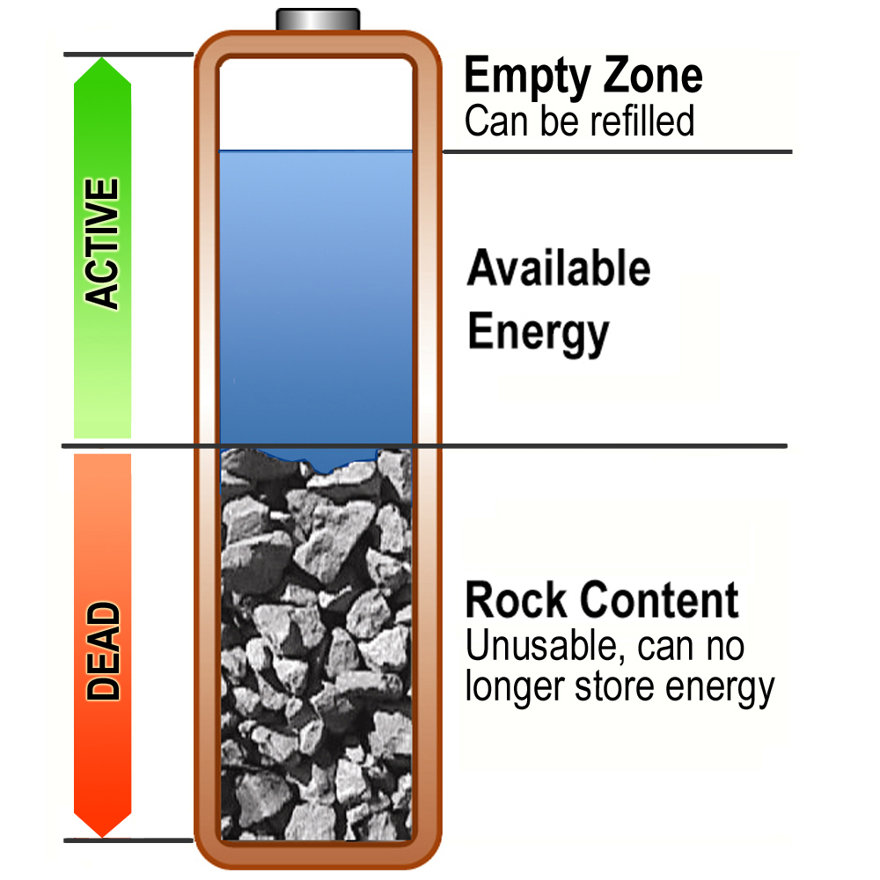

Five Tips to Service Hospital Batteries
1 | Check incoming batteries before placing them in service. Lead acid should have 2.10V per cell (6.30V on 6V pack and 12.60V on 12V unit. Return to vendor if low.
2 | Prime new lead acid batteries to maximize capacity; condition nickel-based batteries to reverse capacity loss. Check all rechargeable batteries for capacity fade. Replace if less than 80%.
3 | Treat a battery like any other medical device. Keep track of the vendor, price, purchase date, start date, performance history and retirement.
4 | Do not replace a battery based on date-stamp; rely on the performance instead. A pack may fail before expiry date, most last twice as long.
5 | Routinely check the spare capacity after a mission to assure extra capacity for longer assignments. The AUTO program of the Cadex C7x00 allows such measurement.
Choosing the right Battery Analyzer
The Cadex C7000 Series perform all functions with minimal effort. Automated programs permit plug-and-play; manual operation enables setting of unique parameters.

Cadex C7200 Two-station battery analyzer provides 40 watts of charge power at 4A per station. The maximum battery voltage is 16V. Cost effective choice for smaller volume or decentralize use.
Cadex C7400 Four-station battery analyzer offers the most economical price per station. Extra stations add flexibility and increase throughput. The power of 55 watts per station enables the service of larger batteries.
Cadex C7400ER At 170 watts of charge power, 6A per station and a battery voltage programmable up to 36V, this extended range battery analyzer is best suited for medical batteries in healthcare.
System Configuration
Batteries in daily use should be serviced every 1–3 months. A 4-station battery analyzer processes 160 batteries based on a monthly maintenance schedule. | Automated functions reduce the time to service a battery fleet to about 30 minutes per day. Payback is less than one year.

Cadex Electronics Inc. | ISO 9001, ISO 13485
22000 Fraserwood Way, Richmond, BC, Canada V6W 1J6  Tel: 604 231-7777; 800 565-5228; Fax: 604 231-7755 |  | Farmstrasse 91-97, D-64546 Moerfelden-Walldorf, Germany Tel: +49 (0) 911 2403 32-0; Fax: +49 (0) 911 2403 32-29
info@cadex.com www.cadex.com

